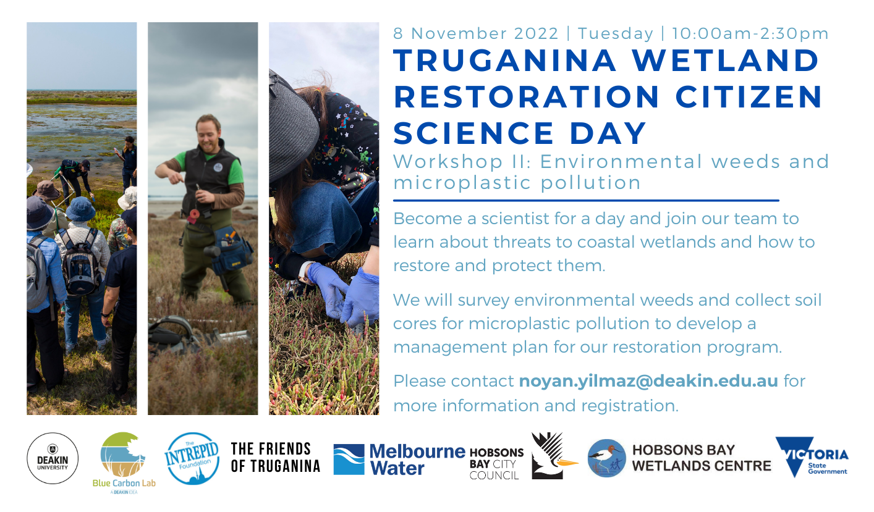

Title: | Restoration of an urban coastal wetland informed through citizen science research  Truganina Workshop II -Environmental weeds and plastic pollution
Date & Time: | Tuesday, November 8th, 2022  10 am – 2:30 pm
Meeting point: | Please make your own way to:  Truganina Swamp  37 Bell Avenue Altona 3018  - There are free on-street parking options.  - Nearest rail station is the Westona Station, which is a 14-minute walk to the meeting point.  - Bus #415 stops at 50 m to the meeting point.
Event Description: | Become a scientist for a day and participate in coastal wetland research!  Truganina Wetland is a 175-ha wetland of Biodiversity Significance, providing critical habitat for threatened and protected fauna as well as threatened saltmarsh vegetation. However, particular areas of this wetland need restoration due to pressures from a range of urban threats.  With the help of local citizen scientists from Friends of Truganina Wetland (FOTW) and Melbourne Water, the Blue Carbon Lab will undertake both a feasibility assessment to determine the causes of degradation, as well as restoration actions to optimize the recovery of the saltmarsh habitat.  Join our team from the Blue Carbon Lab, Friends of Truganina, Melbourne Water, Hobsons Bay City Council and Hobsons Bay Wetland Centre to learn about coastal wetlands and how to monitor all the ecosystem services they provide.  Field activities will include (1) identification of weed species, (2) survey of vegetation plots, (3) elevation measurements using RTK (4) surveying Laverton Creek for plastic pollution.  Program  10:15– 10:45 am Introduction to coastal wetland and restoration research  10:45 – 11:00 am. Demonstration of field techniques  11:00 – 2:30 pm Fieldwork in Truganina Wetland  - All fitness levels are welcome.  - Please bring your own lunch.  - A field trip briefing will be provided to the participants. This will include instructions on how to prepare for the fieldwork (e.g. what to bring) and details of the research project and team of scientists.
Registration | Register for Citizen Science Day by emailing the “Registration form” to noyan.yilmaz@deakin.edu.au.
Organiser | Deakin University's Blue Carbon Lab in partnership with Friends of Truganina and Melbourne Water.  This program is funded by the Victorian Government through the Port Phillip Bay Fund 2021 Grant and Intrepid Foundation.

